ASSIGNMENT 8

Que 1. Assume each salesperson has a 12% commission write a query on the orders table that will produce the order number ,the salespeople number, and the amount of the salespeople commission for that order.
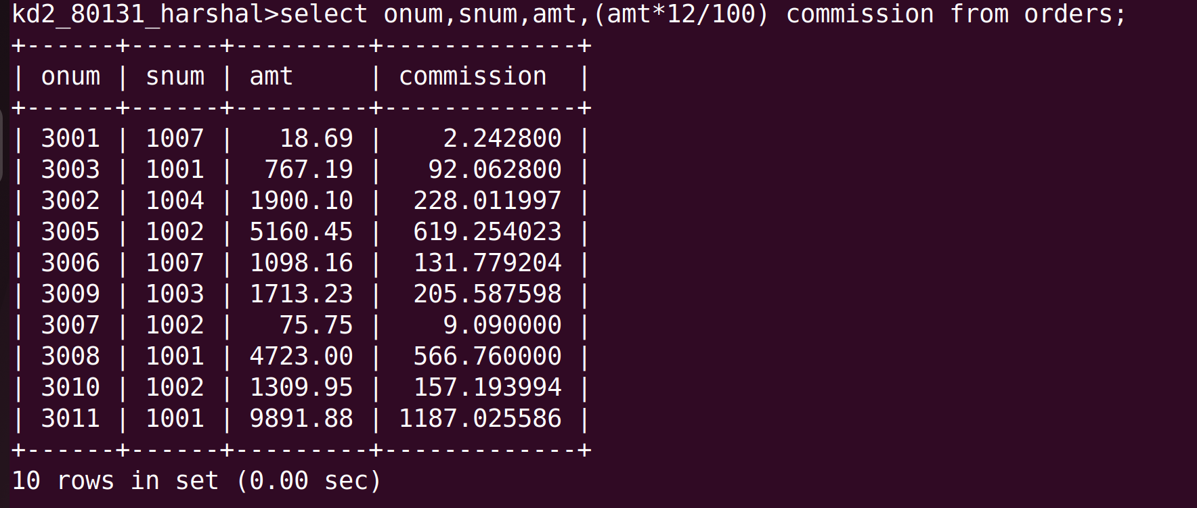
Que 2. Write a query on the customers table that will find the highest rating in each city . Put the output in this form;
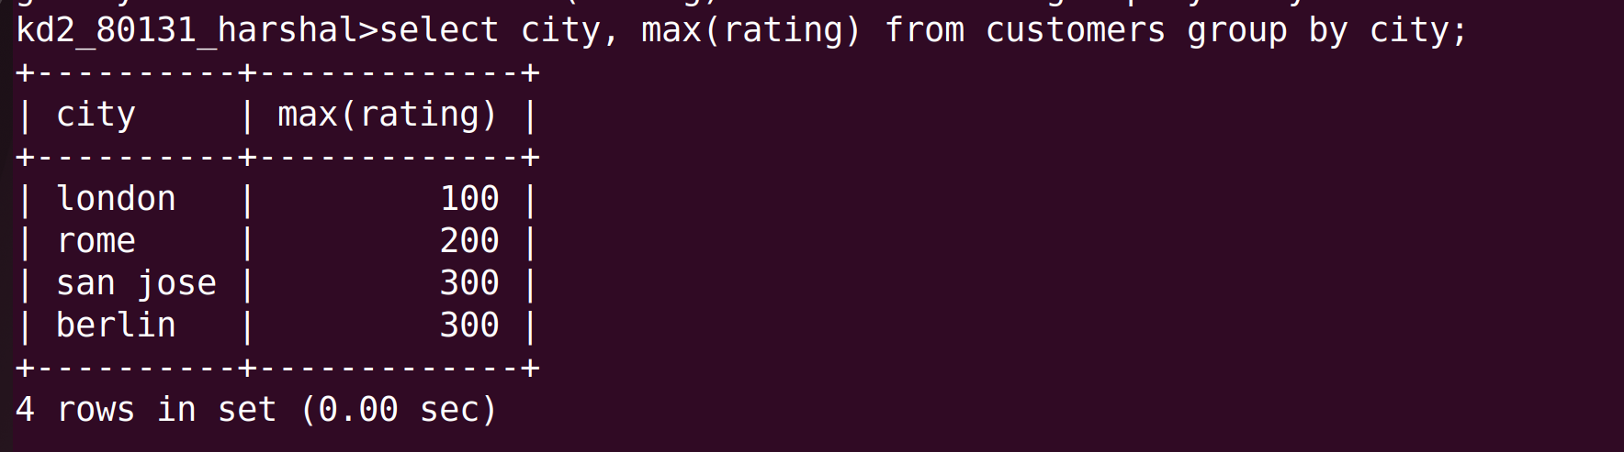
for the city , the highest rating is : (rating)

Que 3.Write a query that lists customers in descending order for rating output the rating field first, followed by the customers name and number.
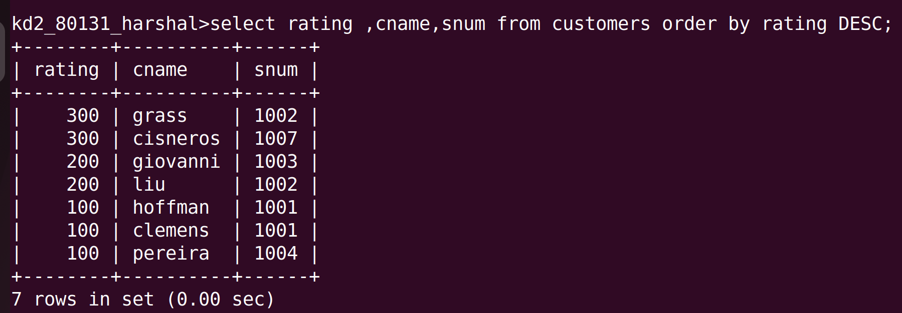
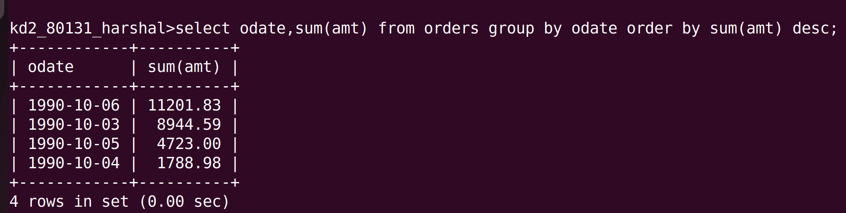
4. write a query that totals the orders for each day and places the result in descending ordrer .

